Quiltmaking

College of Marin – Community Education

Spring 2021- Online Classes

4883 – 7 Classes, April 3 – May 15
Saturdays 10:10 am – 12 noon
7 Saturday classes
Instructor: Patricia Bruvry
Email: pbruvry@comcast.net10$10.00$10
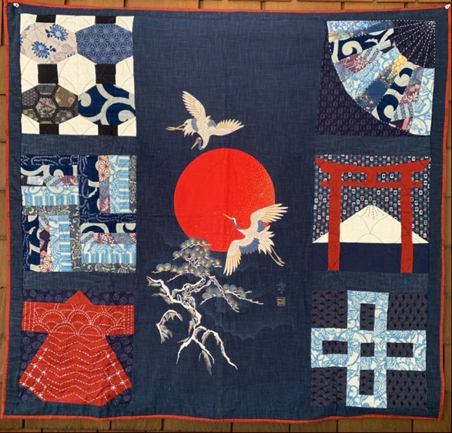
In this online class, we will be focusing on Japanese designs. Instructor will present 4 blocks that can be made into a four-block sampler quilt. Each week, students will learn a new technique for a block. These blocks will cover a variety of techniques that will enable the quilter to proceed to a quilt of his/her own choosing.
In order to sign up for the class, please go to: marincommunityed.augusoft.net
4883 Cost: $112.00
All registration must be done online.

